**Analysis Overview & Report**

**Objectives**

* **Sales and Profit Performance Dashboard**

To monitor strengths and weaknesses:

1. Which **state** is generating the most sales?
2. Which **city** is generating the most sales?
3. What is the top **segment** on sale?
4. What is the **total** **sales** amount till 2017?
5. What is the **total** **profit** amount till 2017?
6. What is the **top** **profitable** product?
7. What are the **top** **10** **cities** on sales?
8. What is the **segment** distribution on sales?
9. How is the **YOY** growth? (Sales vs Profit)
10. What are the **top** **10** **States** on sales?
11. What is the **category**-**wise** profit and sales?

* **Customer Insights Dashboard**

To measure customer loyalty and experience:

1. Who are the **top** **5** **customers** on sales?
2. What is the **average** **shipping** time on each ship mode?
3. Which **ship modes** are used most?

* **KPIS Dashboard**

To measure employees performances:

1. Which **employee** is **contributing** most?
2. How much **target** did they achieve?

**Steps Used**

1. Understand Data
2. Data Cleaning by ‘Power Query’ in Power BI
3. New measures using DAX (Ex. Top city on sale, Top State on sales, Top profitable product, Lowest profitable product, Top segment)
4. Proper chart
5. Customized colours and background dashboard

**Tools Used**

Excel, Power BI

**Detail Report**

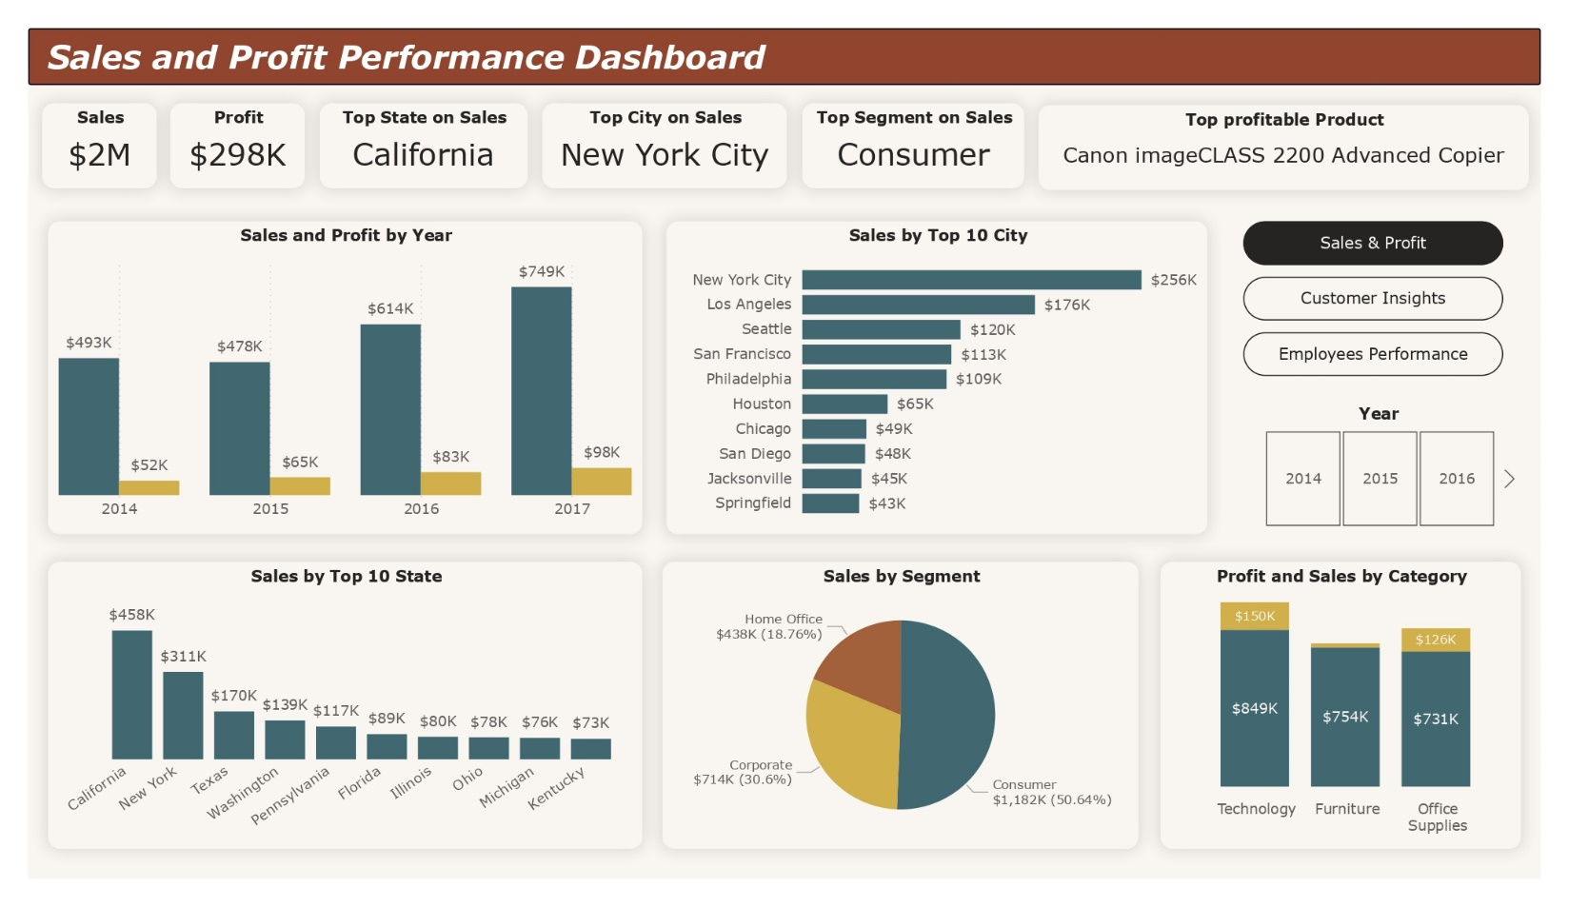**Sales and Profit Performance Dashboard**

To monitor strengths and weaknesses:

1. Total sales till 2017: $2M
2. Total profit till 2017: $298K
3. Top State on Sales: California
4. Top City on Sales: New York City
5. Top segment on sale: Consumer
6. Top profitable product: Canon imageClass 2200 Advanced Copiler

|  |  |
| --- | --- |
| 1. New York City 2. Los Angeles 3. Seattle 4. San Francisco 5. Philadelphia | 1. Houston 2. Chicago 3. San Diego 4. Jacksonville 5. Springfield |

1. Top 10 cities on sales:
2. Segment distribution: Consumer ($1,182K, 50.61%), Corporate ($714K, 30.6%), Home Office ($438K, 18.76%)
3. **YOY** growth:

|  |  |  |
| --- | --- | --- |
| **Year** | **Sales** | **Profit** |
| 2014 | $493K | $52K |
| 2015 | $478K | $65K |
| 2016 | $614K | $83K |
| 2017 | $749K | $98K |

1. Top 10 States on sales:

|  |  |
| --- | --- |
| 1. California 2. New York 3. Texas 4. Washington 5. Pennsylvania | 1. Florida 2. Illinois 3. Ohio 4. Michigan 5. Kentucky |

11. Category-wise sales and profit:

|  |  |  |
| --- | --- | --- |
| **Category** | **Sales** | **Profit** |
| Technology | $849K | $150K |
| Furniture | $745K | $22K |
| Office Supplies | $731K | $126K |

**Customer Insights Dashboard**

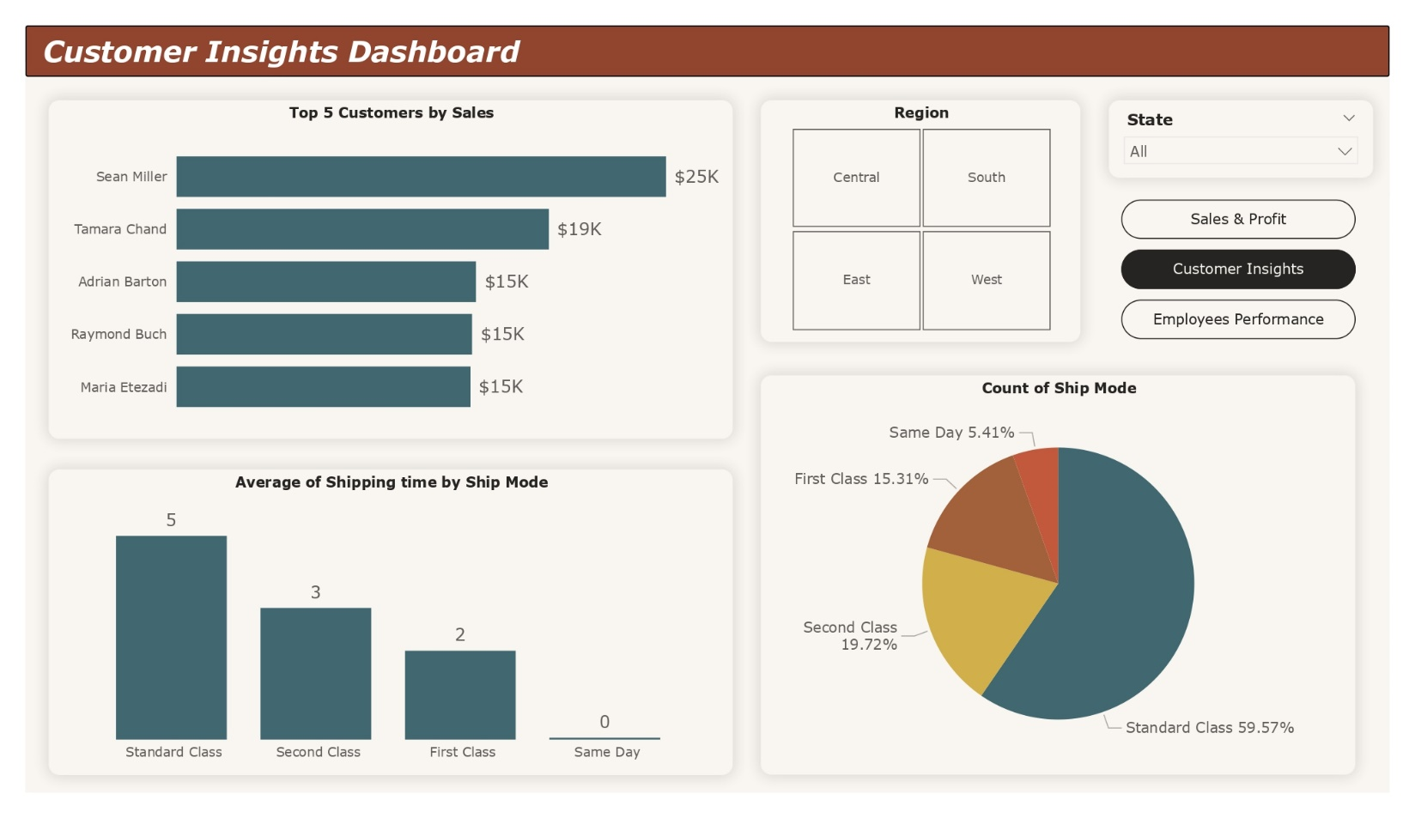

To measure customer loyalty and experience:

1. **Top** **5** **customers** on sales:

* Sean Miller is the Top customer who ordered the most is $25K.
* Tamara Chand is the second top customer who ordered $19K.
* Adrian Barton is the Third top customer who ordered $15K.
* Raymond Buch is the Third top customer who ordered $15K.
* Maria Etezadi is the Third top customer who ordered $15K

1. **Average** **shipping** time on each ship mode:

* Standard class Shipping Mode is taking avg. 5 days, is the most time taking.
* Second class Shipping Mode is taking avg. 3 days, is the 2nd most time taking.
* First class Shipping Mode is taking avg. 2 days.
* Same Day Shipping Mode is taking the least time.

1. **Ship modes** are used most:

* Standard Class is used as the highest ship mode (59.57%).
* Second Class is used as the 2nd highest ship mode (19.72%).
* First Class Ship Mode is used 15.31%
* Same day Ship Mode is used the least 5.41%.

**KPIS Dashboard**

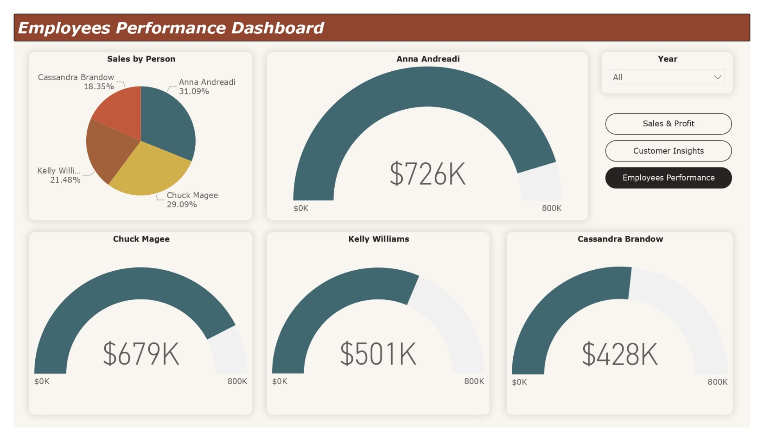

To measure employees performances:

1. **Employee** is **contributing** most:

* Anna Andreadi is contributing the most is 31.09%.
* Chuck Magee is contributing the 2nd most is 29.09%.
* Kelly Williams is contributing the 3nd most is 21.48%.
* Cassandra Brandow is contributing the least is 29.09%.

2. **Target** they achieved:

|  |  |  |
| --- | --- | --- |
| **Name** | **Target** | **Achieved** |
| Anna Andreadi | $800K | $726K |
| Chuck Magee | $800K | $679K |
| Kelly Williams | $800K | $501K |
| Cassandra Brandow | $800K | $428K |